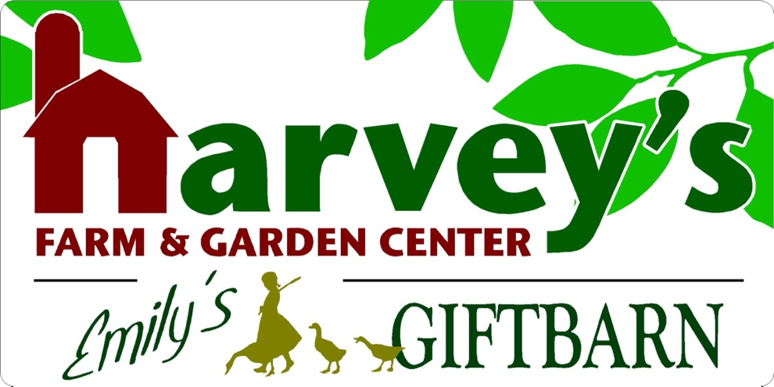
120 South Street • Westborough, MA 01581
harveysfarm.com • 508-366-1545 • emily@harveysfarm.com
Onions, Potatoes & Asparagus…Oh My!
A Planting Guide

Onion Sets
Heavy Feeders
Push the onions into loose soil with just the tops showing
Do not bury the onions beneath the soil
They need Lime (Mag-i-Cal Plus) and Organic Plant Food

Seed Potatoes
Create a trench approximately 6” deep
Be sure to cover/bury any emerging foliage if there’s going to be a frost as this is the most tender part of the plant.
Remove any micro weeds by shallow scraping of the soil surface.
The trench becomes a hill of potatoes over time and repeating the covering of emerging foliage. Harvest when plant dies back.

Asparagus
Heavy Feeders
Create a trench approximately 6” depth. Start as a trench and end up in a hill. Plant asparagus plants at the same depth they’re currently planted at.
Try not to cover foliage.
Use lots of Lime (Mag-i-Cal Plus) and Organic Plant Food

