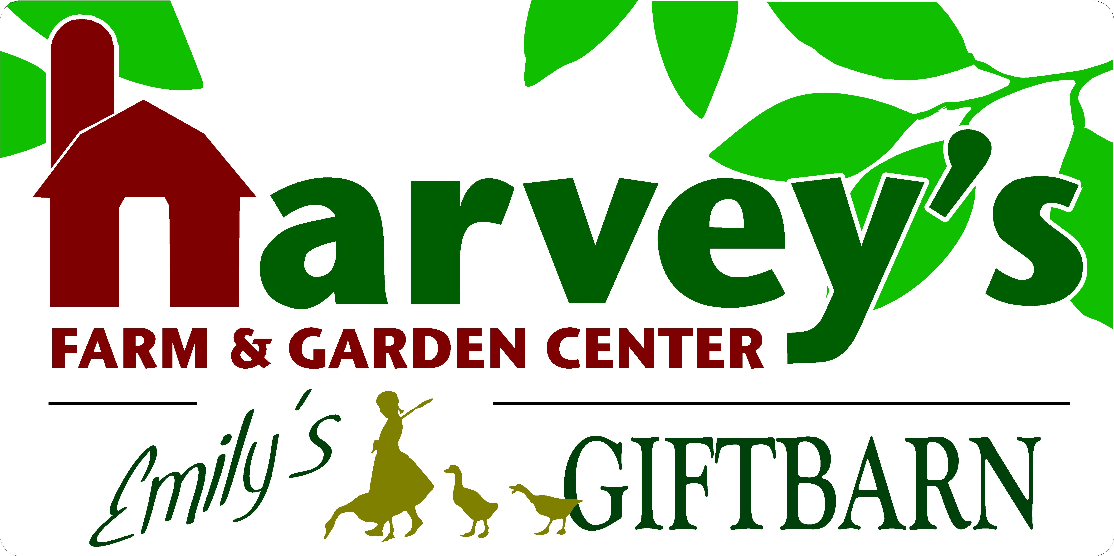
7 Maple Avenue • Westborough, MA 01581
508-366-1545 • www.harveysfarm.com • emily@harveysfarm.com

“Contain Yourself” Customer Guide

Materials & Supplies
- The “Dirt” on Soil; Create a $10 hole for a $5 plant; the correct soil for the project, “healthy soil, healthy plants, happy & healthy you!”
- Choosing the Right Container Drainage is a MUST (at least highly recommended to avoid drowning plant/over-watering)
- Plant Selection for Sunlight Exposure | Location of Container | Mobility?
- Plant is grown in one pot, treat it as one plant; Do not disturb/rip apart root structure

Simple Combinations for Success
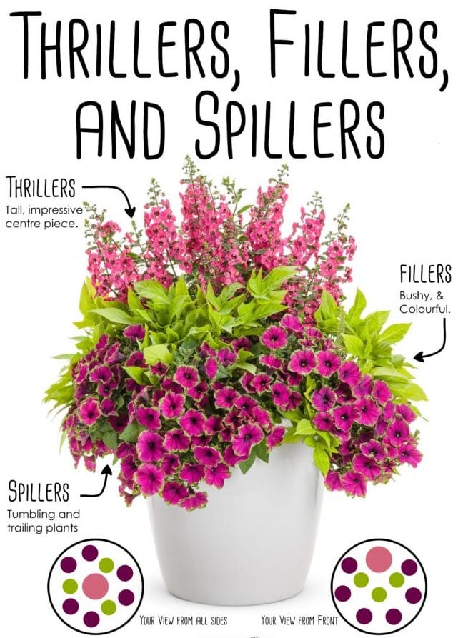
- The Wow Factor- “Thrillers, Fillers and Spillers”
- Designing in Odd Numbers is most pleasing to the eye
- Annuals: Long-lasting color throughout season, big drama all season long
- Herb & Veggie Gardens, Small Fruit Plants Like Strawberries, easy access for regular use
- Perennials/Compact Shrubs CAN be used, but keep in mind much shorter show/less drama, need permanent (ground) home after container to extend life/performance long term
- Combining veggies/herbs/small fruits and ornamentals is “a-ok!” – no plant police, just give ample space to plan for mature growth habits

Watering & Basic Care
- Advantages of smaller, lightweight containers

- Check often, water when necessary

- Deadheading plants (varieties only when necessary); promoting bud formation, improving appearance, haircuts “cruel to be kind” and regular feeding a must!

Questions & Notes

