7 Maple Ave• Westborough, MA • 508-366-1545
harveysfarm.com • emily@harveysfarm.com

Harvey’s Planting Guide: Perennials, Trees & Shrubs

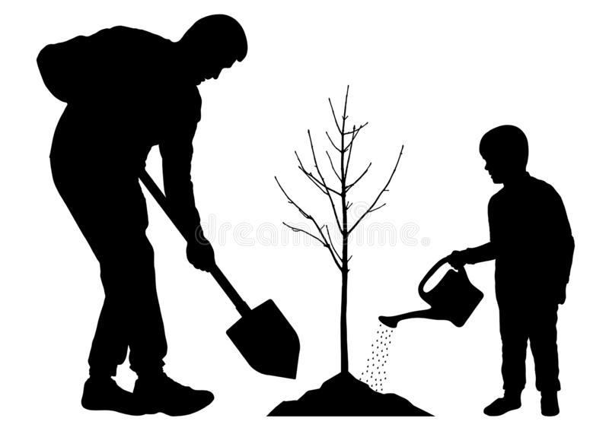
The “Dirt About Soil” “Make a $10 Hole for a $5 Plant”
You only have one chance to plant something permanent like a perennial, tree or shrub. Plant it once, plant it right. The more you surround your investment with high quality environment, the greater the success will be. Not all “dirt” is created equal. Select a high quality, organic product like Coast of Maine’s Penobscot Planting Mix. We recommend a starter fertilizer, higher in phosphorus to help stimulate rooting and assist with more rapid establishment.

Plant Selection & Sunlight
What is Sunlight in this area? Full Sun to Full Shade and everything in between, watch the area throughout the day and throughout the seasons so we have an accurate idea of how much sunlight there is. The more sunlight, the more choices you’ll have. For fruiting trees and plants, full sun is typically required for both flower and ample fruit production.

Feeding
We only want to feed early in the spring and only up until the beginning of summer. We don’t want to stimulate new growth leading into cooler months to help avoid winter damage.

Fruit Trees & Plants
These plants should only be fed organically. Just a reminder, many of the fruit plants and trees need cross-pollination. Even self-pollinating varieties will produce better having another variety to cross pollinate with. With blueberries, you need to cross-pollinate with two different early varieties, two different mid-season varieties or two different late-season varieties to cross-pollinate and have productive plants.

Watering Habits & Routines
Although new plantings require just a bit more monitoring, we want to encourage both new plantings and established plantings in the ground (vs containers) to reach deeply to find moisture. If and only when we water, we want to water deeply meaning a larger volume of water over a longer period of time less often (mimicking a gentle, beneficial rain) vs everyday for just a few minutes “because you want to protect your investment.” Roots that are stressed to reach deeply for water in the soil are stronger, healthier, less drought-sensitive, hardier and less disease and insect prone. Less work for you and healthier for the plant!

