Harvey’s Gardening Guide

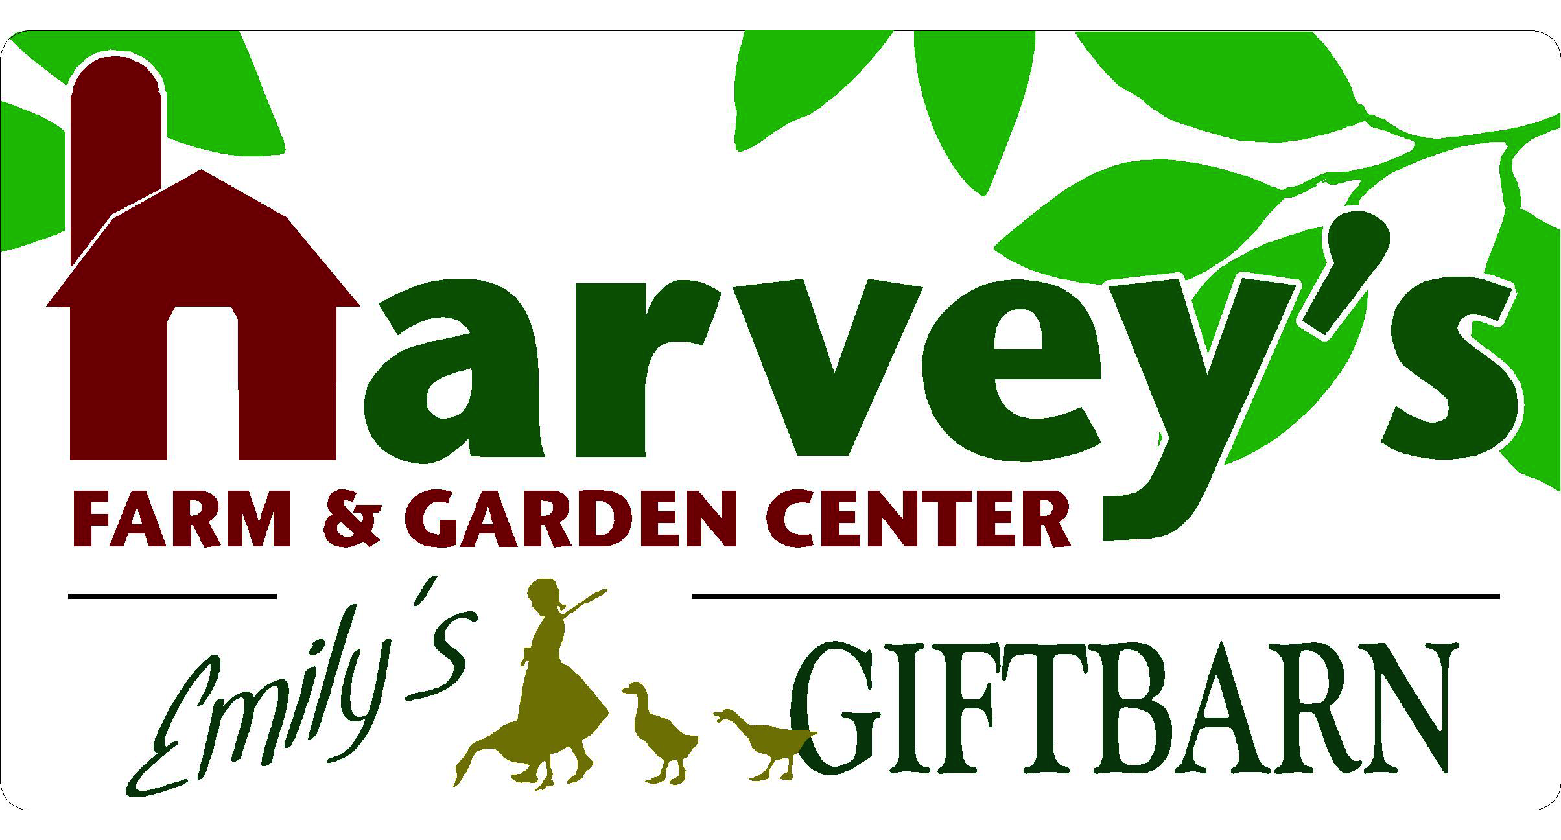
120 South Street Westborough, MA • 508-366-1545
harveysfarm.com • emily@harveysfarm.com

Location & Scale – Where Will Your Garden Be Located? How Big or Small?
- Movable Containers or Planted in the Ground/Raised Beds?
- The More Sun in the Area, the More Choices You Have of What to Grow
- Start small and build on SUCCESS!
- Tall Plants (like tomatoes) should be placed on North Side of Garden, Don’t Save Space for Lettuce, use it as a “plug-in” crop in between your taller plants; the shade will help keep it cool & happier too!

Plant Selection & Sunlight-
- What Sunlight - Full Sun to Full Shade and everything in between, watch the area throughout the day and throughout the seasons
- What do you like to eat? How big is your family?

The “Dirt” About Soil – Soil Testing - When in doubt, find out!
- Essential Nutrients, Organic Matter & Texture, Horse Manure (no value)
- Nutrients (Coast of Maine Stonington Organic Plant Food or Coop Poop) & Calcium (Mag-i-Cal) are water-soluble need to be applied at least twice in a season. Every time it rains or the garden is watered, the concentration of the nutrients is diluted. We recommend reapplication of these products every 4-6 weeks as a topdressing
- Old, Compacted Dirt – Change It and Add Nutrients
- “Healthy Soil, Healthy Plants…Healthy You!” = Feed the Soil so it Feeds You

OPTION A: Coast of Maine Raised Bed Mix- Easy to Use Option is the Coast of Maine Organic Raised Bed Soil which is a complete planting mix which is available in 2cu ft bags. We still recommend additional organic fertilizer (Coast of Maine Stonington Organic Fertilizer or Coop Poop) and additional lime (Mag-i-cal) for reapplication every 4-6 weeks as the raised bed mix only contains ingredients for initial planting.

OPTION B: “Garden Cart Combo” suggested application for approx 100-150ft² Other Options Available for smaller/larger areas
- 1 Peat Moss (3.8 cubic ft) – Using an iron rake/pitch fork, break apart compressed bale of peat moss, spread evenly over entire garden
- 2 Composted Cow Manure - Use both bags, spread evenly over peat moss
- 1- 25# bag Coop Poop (pelletized, dehydrated chicken manure): sprinkle full bag over cow manure
- 1 – 1M bag of Mag-i-Cal : Sprinkle full bag over COOP POOP.
- Incorporate/Mix/Rototill
- Plant– There’s no sense in having a garden full of water-soluble nutrients, then it rains, and the nutrients aren’t feeding any plants
- Re-Apply Fertilizer & Lime- Reapply Every 4-6 weeks (or more frequently if we have had a lot of rain)
+ Additional Mag-i-Cal (Lime) + Additional Organic Nutrients (COM Organic Plant Food or Coop Poop)

Watering- “A human with a hose is the kiss of death,” says Farmer Harvey
- The problem is too much frequency, not enough volume of water – better to be out once/week for 30 mins than 7 days a week for 5 mins roots will follow the moisture deep healthier plants. If shallow watering habits, roots will remain shallow, disease-prone, addicted to unnatural watering habits
- Containers vs. Planted in the ground – Are containers able to picked up to test weight? Most of a plant’s weight is the water – heavy = lots of moisture, light= may need a drink (depending on the plant)

“Feed Me” – Plants Need to be Fed, Just Like People
- Flowering Annuals -Proven Winners Water-Soluble Plant Food (necessary application weekly) for Flowering Annuals vs. Proven Winners Continuous-Release Plant Food (the “insurance policy”- Monthly Application)

- Veggie Gardens -Be sure to reapply fertilizer and lime at least twice or three times during a season. We recommend re-application every 4-6 weeks for “annual” crops. As the season progresses, it’s rained/you have watered, the plants have taken up nutrients and are getting bigger, but less nutrients are present in the soil…time to FEED & LIME!

- FOR FRUIT TREES & PLANTS- Where these are perennials, we only want to feed early in the spring and only up until the beginning of summer. We don’t want to stimulate new growth leading into cooler months to help avoid winter damage. These plants should only be fed organically. Just a reminder, many of the fruit plants and trees need cross-pollination. Even self-pollinating varieties will produce better having another variety to cross pollinate with. With blueberries, you need to cross-pollinate with two different early varieties, two different mid-season varieties or two different late-season varieties to cross-pollinate and have productive plants.
Questions/Notes:

